- Expand Gap Analysis (Section II.F) with a comparison table against recent works (include more 2024–2026 PQC-drone papers). Stress "first MAC/RRC-layer hybrid with mobility caching in full 5G-LENA stack for swarms up to 80 UEs."
- Reduce the content of the last section (conclusion and future work). Change the limitations section to a paragraph instead of bullet points.
- Avoid too much usage of subheadings and bullet points; it leads to an assumption of AI content.
- Add a "Threat Model" subsection.
- Refine Contributions
  - Hybrid protocol details (add pseudocode clarity or sequence diagram if space allows).
  - Caching mechanism + security analysis (strengthen with threat model table).
  - Comprehensive NS-3 evaluation (scalability, energy, PDR).
- Crypto & Security
  - Expand Proposition 1 with more details or reference a formal hybrid KEM proof (Bindel et al. is good; consider citing recent multi-stage analyses).
  - Discuss side-channel resistance, constant-time implementation, and parameter choices more (why Kyber-768 exactly?).
  - Add key revocation/caching attack mitigation experiments or analysis.
- Simulations
  - Increase Monte Carlo runs (to 30–50) for tighter CIs.
  - Add multi-cell/Xn handoff scenarios (addresses a key limitation).
  - Include NLoS/urban models (3GPP TR 36.777) and compare.
  - Benchmark against more baselines (pure Kyber, other hybrids).
  - Energy: Refine model (include memory, idle power); add sensitivity analysis.
- Ensure high-resolution, clear captions, and consistent styling. Replace placeholder screenshots with proper embedded figures. Add error bars everywhere.
- Abstract, Intro, and Related Work overlap (e.g., quantum threats repeated). Trim and use forward references.
- Clarity & Flow
  - Use numbered lists for contributions and protocol steps.
  - Shorten long sentences; improve transitions.
  - Consistent terminology (e.g., gNB vs. base station).
- If possible, add an ablation study.

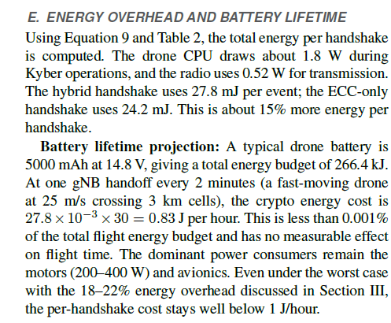

Avoid these kinds of subheadings inside a subsection, and avoid too many subsections.

